**Station 3: Transition Tennessee’s Student Website**

**Learning Target:** Develop a station map using TransitionTN’s “Participating in College Experiences” lesson.

**Station Goal:** Participants will understand how to use Transition Tennessee’s Student Website.

**Time:** 25 minutes

**Structure:** Instructor-led

**Directions:**

**Step 1:** Go to TransitionTN's student website. If needed, use the navigation support on page 2 while we explore the student website.

**Step 2:** Explore the Transition Tennessee Student Website as a group. We will focus on the “Participating in College Experiences” student lesson. Navigate to this lesson by:

* Go to www.transitiontn.org/student
* Click on "I Want to Continue My Education"
* Select the course “What Community Activities Can Help Me Continue My Education?”
* Select the “Participating in College Experiences” student lesson

**Step 3:** Review the different features of the “Participating in College Experiences” lesson as a group.

* Role-play
* Get Involved Activities
  + Vocabulary cards
  + Game
  + Fact sheet
  + School-based activity
  + Community-based activity
* My Portfolio

**Step 4:** With a partner, design three stations using all the features in the “Participating in College Experiences” lesson. Create your stations using the Station Map on page 3 and an exit ticket on page 4.

**Step 5:** Share your station ideas for the “Participating in College Experiences” lesson with the group.

**Step 6:** Review the Student Website Index on page 5 for additional student lesson information.

**Evaluation:** Completed station map

**WEBSITE NAVIGATION SUPPORT**

**To Navigate to the TransitionTN Student Website:**

1. Go to TransitionTN.org
2. Login to your TransitionTN account or click the blue “Register” button to create an account



1. Then, click on “FOR STUDENTS” at the top of the webpage or by scrolling to the bottom of the TransitionTN.org homepage and clicking “Let’s Go!”



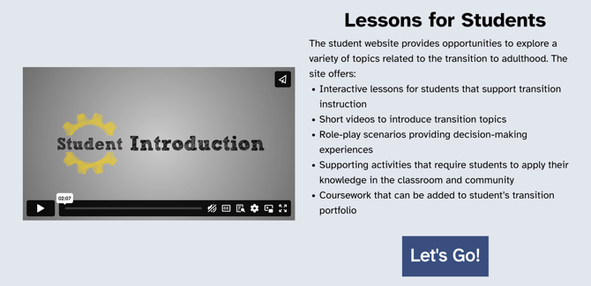

1. When you get to TransitionTN’s student website, you will see three options: I want to go to work, I want to continue my education, and I want to live an independent lifestyle



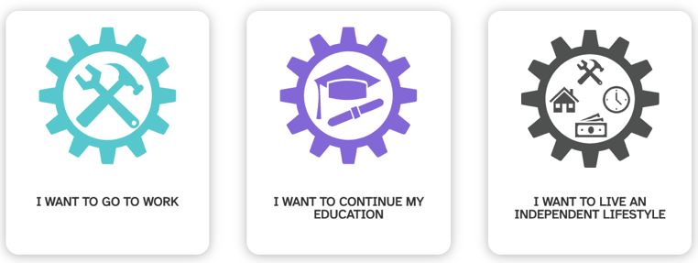

1. Additional exploration: To get a complete list of the student lessons, click on “Lessons” at the top of the page. Then click on “Lesson Index.”

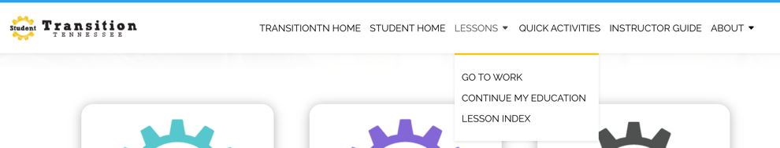

**Station Map**

**Learning Target:** At the end of this activity, students will be able to identify college experiences they would like to participate in while in a college or training program.

Station 1: Instructor-led

Station 2: Independent Activity

Station 3: Group Work

Time:

Time:

Time:

Time:

Time:

Whole Group Closing:

Whole Group Pre-Teaching:

**Evaluation:** Exit Ticket

After completing all station activities, students will answer the following questions.

Question 1:

Question 2: