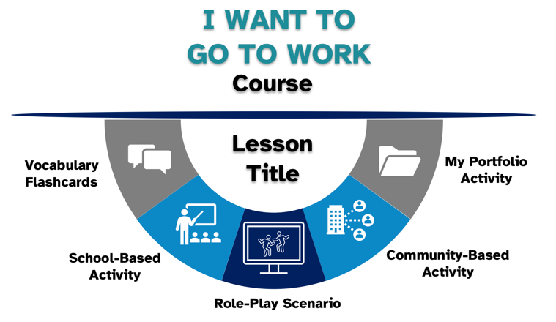  TransitionTN Student Website: Lesson Bank | 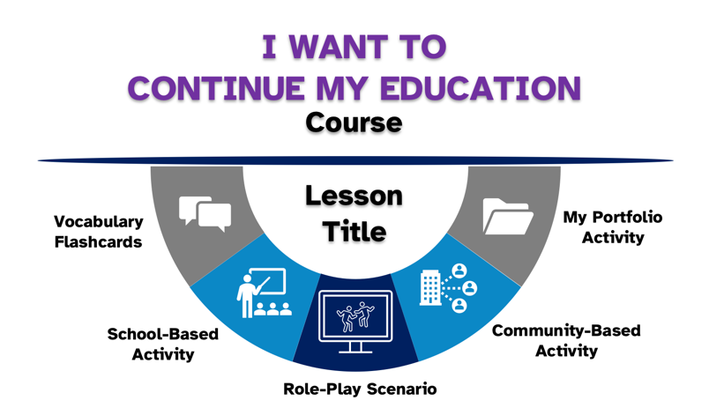 | 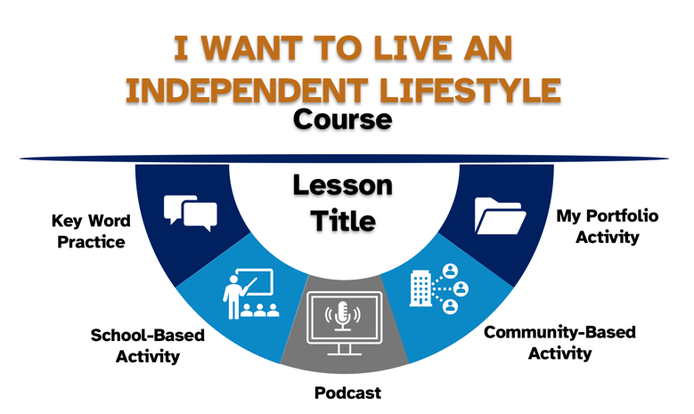
How Do I Explore My Work Options?  - Self-Assessments  - Labor Market and Types of Employment  - Benefits of Going to Work  What Are My Needs, Rights, and Responsibilities at Work?  - Rights and Responsibilities Change After High School  - Disability Disclosure in the Workplace  - Communication in the Workplace  What Resources and Services Can Help  Me Get a Job?  - Gathering Your Resources  - Vocational Rehabilitation  - Community Resource Mapping  What Community Activities Can Help  Me Get a Job?  - Networking to Get a Job  - Experiences to Learn about Work  - Participating in Work Experiences | How Do I Explore My Options for  Continuing My Education?  - Types of Postsecondary Education  - Preparing to Continue My Education  - Career Pathways and Goals  What Are My Needs, Rights, and Responsibilities When I Continue My Education?  - Rights and Responsibilities Change After High School  - Disability Disclosure in the College  - Communication College  What Resources and Services Can Help  Me Continue My Education?  - Gathering Your Resources  - Vocational Rehabilitation  - Community Resource Mapping  What Community Activities Can Help  Continue My Education?  - Networking to Continue My Education  - Experiences to Learn about College  - Participating in College Experiences | How Can I Be Independent with My Finances?  - Banking Basics  How Can I Be Independent at Work?  - Workplace Policies
Quick Activities
- Accommodations in College
- Assertive Communication
- Campus Tours
- Career Fairs
- Career Clusters and CTE
- Certified Work Incentives Counselors
- College Fairs
- Communicating in Job Interviews
- Job Accommodations
- Keeping Your Resources Organized
- Living Away From Home
- Online Searches
- Professional Emails
- Self-Assessments
- Social Security Benefits
- Types of Employment
- Understanding Your PINS
- Vocational Rehabilitation Counselors
- VR Customer Responsibilities

