Preparing Community Members for Community- Based Experiences
After you have recruited community members to participate in community-based activities, it is important to inform them about the purpose of the activity. Sending information about expectations before the experience can help the community participant to prepare and tailor the experience to the learning objectives you have for your students. Below you will find an example of a letter that can be sent to community members prior to an activity. See page 2 of this document for a fillable template you can edit to customize your own letter.
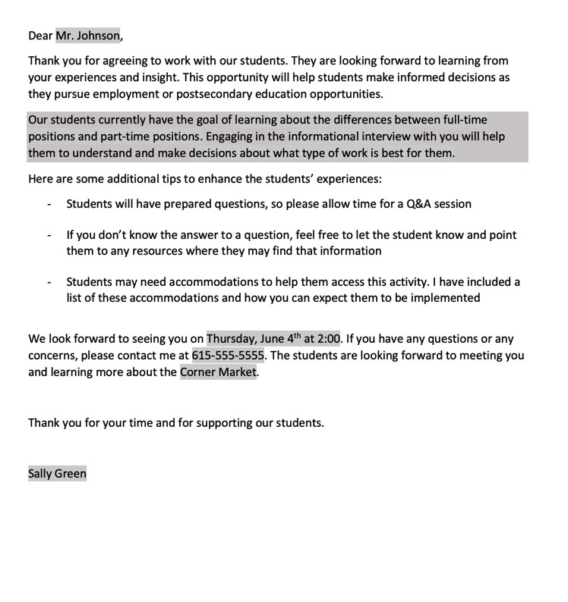

Dear Name of Contact,

Thank you for agreeing to work with our students. They are looking forward to learning from your experiences and insight. This opportunity will help students make informed decisions as they pursue employment or postsecondary education opportunities.
Insert Your Activity Details Here
Here are some additional tips to enhance the students’ experiences:
- Students will have prepared questions, so please allow time for a Q&A session

- If you don’t know the answer to a question, feel free to let the student know and point them to any resources where they may find that information

- Students may need accommodations to help them access this activity. I have included a list of these accommodations and how you can expect them to be implemented

We look forward to seeing you on Date and Time. If you have any questions or any concerns, please contact me at Contact Info. The students are looking forward to meeting you and learning more about Business Name.

Thank you for your time and for supporting our students.

Your Name

