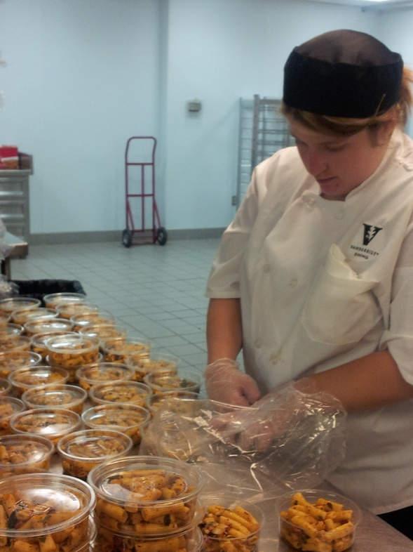

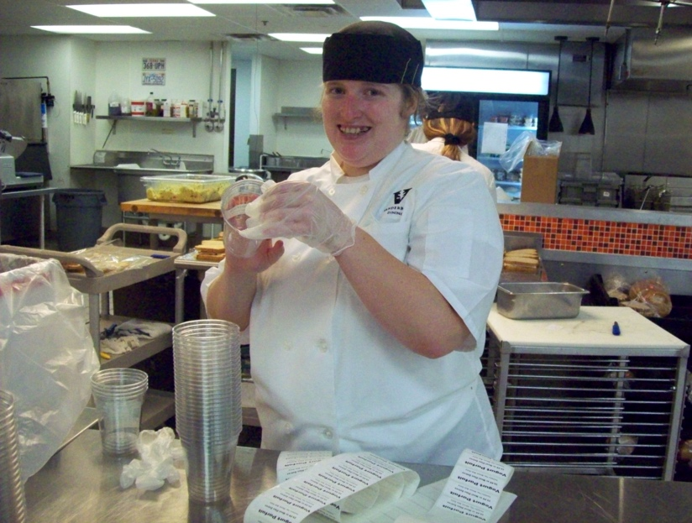

**Skills I Bring to the Job**

Detail Oriented

Organized

Dependable

Attentive Listener

Hardworking

Positive Attitude

### **Supports That Help My Success**

Ask for assistance when needed

Written directions

Visual checklists

**How People Describe Me**

Reliable employee

Teammate

Confident

Supportive

Cooperative

Charismatic

Social

### **Prior Work Experience**

* **PetSmart**

October 2018-Present

* + Stocked
  + Inventory management
* **Morning Pointe Assisted Living** August 2017-May 2018
  + Cleaned tables
  + Replenished supplies
* **School Cafeteria**

September 2016-May 2017

* + Baked cookies
  + Maintained Inventory

**Katie Smith**

(222)555-8888

EMAIL@gmail.com