Course: Strategies for Effective Instruction

Examples of Behavior Supports

Positive Behavior Interventions and Supports (PBIS)
PBIS is an evidence-based three-tiered framework to improve and integrate all of the data, systems, and practices affecting student outcomes every day. Schools use a variety of terms to describe their behavioral services. Make sure to communicate with the teacher and school system to learn their unique terminology and lingo.

Tier 1: Students in this level receive typical behavior supports. Schools provide these supports to all students in the school, making this tier the largest.

Example: All students are instructed to wait for a teacher to dismiss them before leaving class

Tier 2: Students in this level are at risk for developing more serious problem behaviors. This level provides more focused support than Tier 1 and often involves group interventions.

Example: Instructor provides student with a visual schedule when they experience difficulty figuring out what is next in their daily routine

Tier 3: Students in this level receive intensive and individualized behavior supports. This is the smallest tier as 1-5% of students receive these services on average. This level provides supports in the form of individualized plans created by a multi-disciplinary team.

Example: Student receives a Functional Behavior Assessment (FBA), a formal process aimed at identifying behavioral interventions that will be helpful for the student
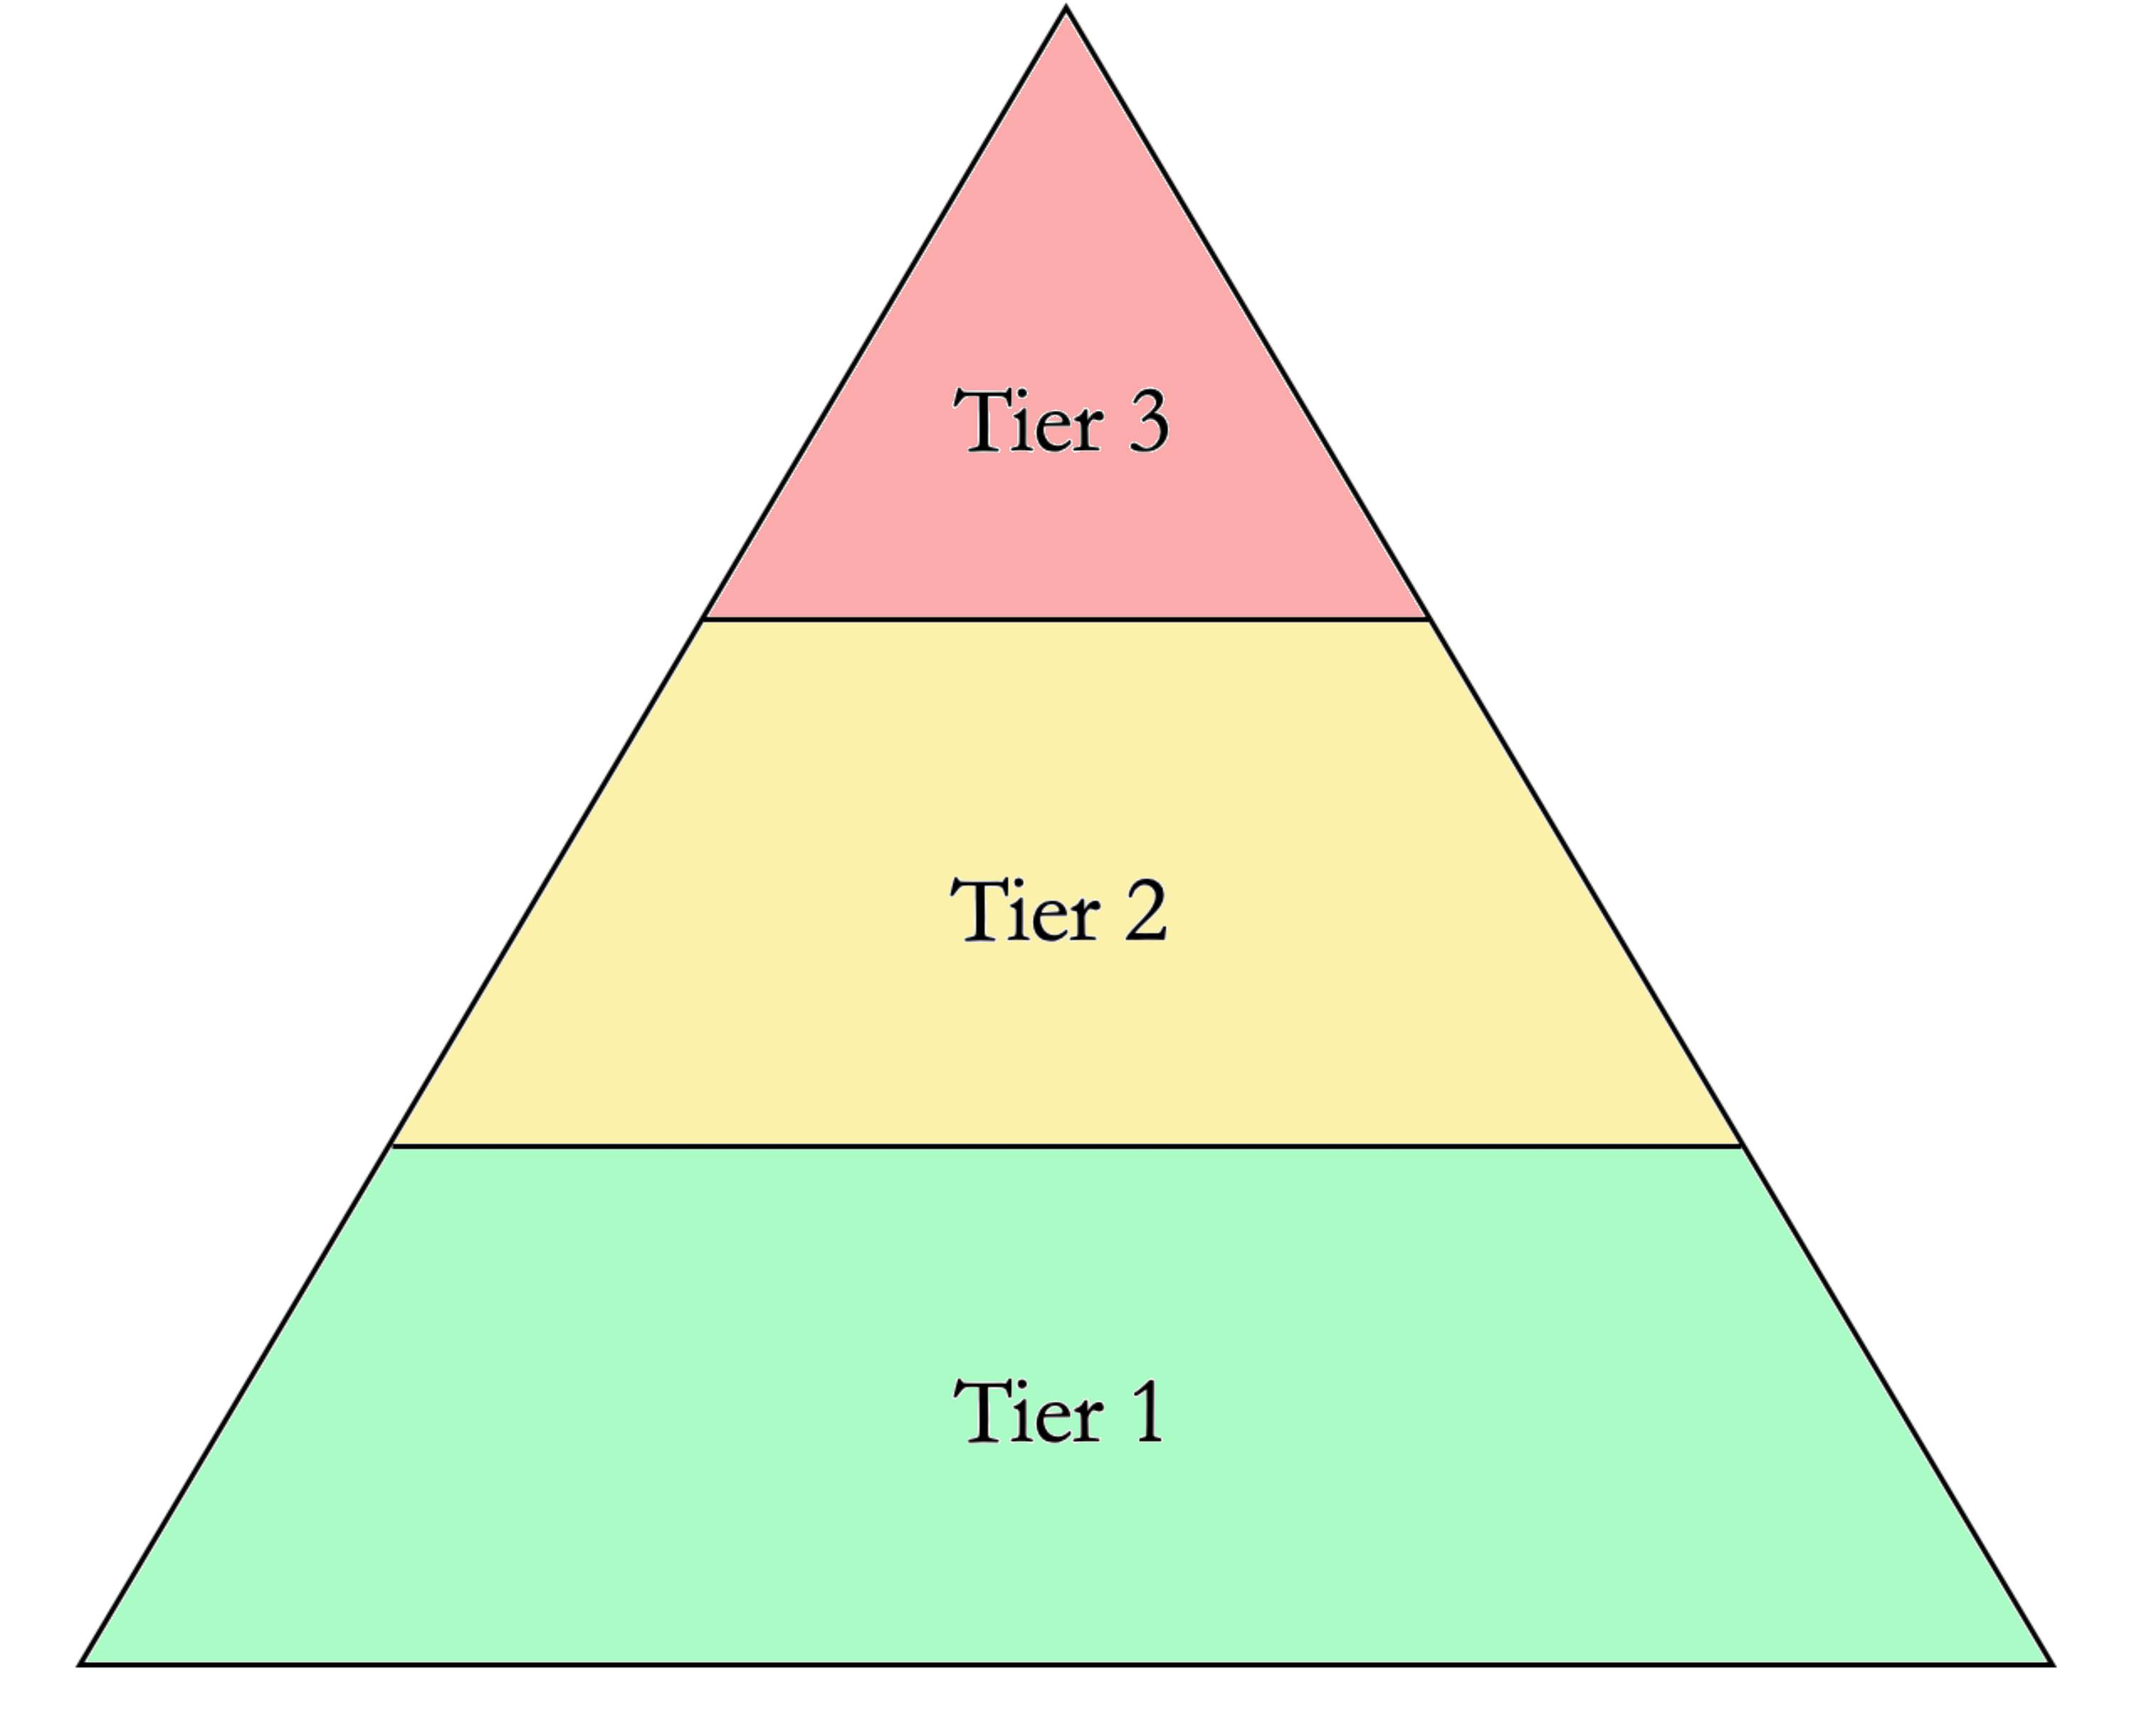

The ABCs of Behavior
The ABCs of behavior is a functional behavior assessment that refers to the Antecedent, observed Behavior, and Consequence related to a particular behavior. This is a commonly used strategy for tracking inappropriate or disruptive behavior.

Antecedent: What was happening right before the particular behavior

Behavior: The particular behavior that the student engaged in

Consequence: What happened right after that particular behavior
- If a behavior is followed by something desirable to the student, that behavior will likely increase. If a behavior is followed by something undesirable to the student, that behavior will likely decrease.

Example 1: Justin is a student at Evergreen High School. His Pre-ETS provider, Mr. Simmons, has assigned a worksheet for the students to do during class. When Justin gets his worksheet, he crumples up the paper and throws it across the room. The students in the classroom all laugh.

Antecedent | Behavior | Consequence | How to change the behavior
Mr. Simmons passes out a math worksheet to the students | Justin crumples up the paper and throws it across the classroom | The students in the classroom laugh  (Behavior will likely increase) | Mr. Simmons creates a system to reward Justin when he completes his work

Example 2: Victoria is a freshman at Canyon High School. During her Transition Work Skills Class her Pre-ETS Provider, Mrs. Marcus, spends the first part of class asking the students about their weekend. When Mrs. Marcus asks the class, Victoria shouts out her answer. Mrs. Marcus reminds her that she needs to raise her hand and wait to be called on to answer a question.

Antecedent | Behavior | Consequence | How to change the behavior
Mrs. Marcus asks the class a question | Victoria shouts out her answer | The other students get annoyed with Victoria and tell her not to shout out her answer. | Before Mrs. Marcus asks a question, she reminds students to raise their hands if they would like to answer. And gives verbal praise to students that follow the directions.

References

PBIS - https://www.pbis.org/

