Poll Everywhere

Description - https://polleverywhere.com
- Platform that allows you to create a question or prompt, while students use a code to respond
- Polls can be in the format of a graphic, word cloud, or graph and will update as students respond
- Students can submit responses with their name or anonymously

Pricing
- Free version allows for audience size of up to 25 people
- $120 per year allows for audience size of up to 700 people

How to Use
Content Review: Using questions about content delivered to students in previous lessons to review concepts
o Example: Prompt: What is one fact you learned about job applications last time we met?
Students respond with short sentence that will come up on a display

Content Delivery: Creating questions based on the lesson’s learning target to monitor student’s
understanding throughout the lesson
- Example: Prompt: Who can you ask for help from when filling out an application?
Student post their answers and as a group you can discuss their responses

Vocabulary Review: Reviewing the definition of new terms and how they can be used in context
- Example: Prompt: True or False? A social security number is the same as your telephone number.
Students respond and a bar graph will formulate based on responses

Assessment: Monitoring student learning
- Example: Prompt: Which of the following would be a good professional reference? Choices: 1st grade teacher, Parent, Volunteering Job Supervisor
Students’ responses will formulate into a bar graph

Brain Breaks: Making learning fun and engaging with a break from the lesson content
- Example: Clickable image of TV or movie characters: “If you could be a character, who would you be?”
Students click the character of their choice and their responses are marked with a pin. Have students share why they chose a particular character.

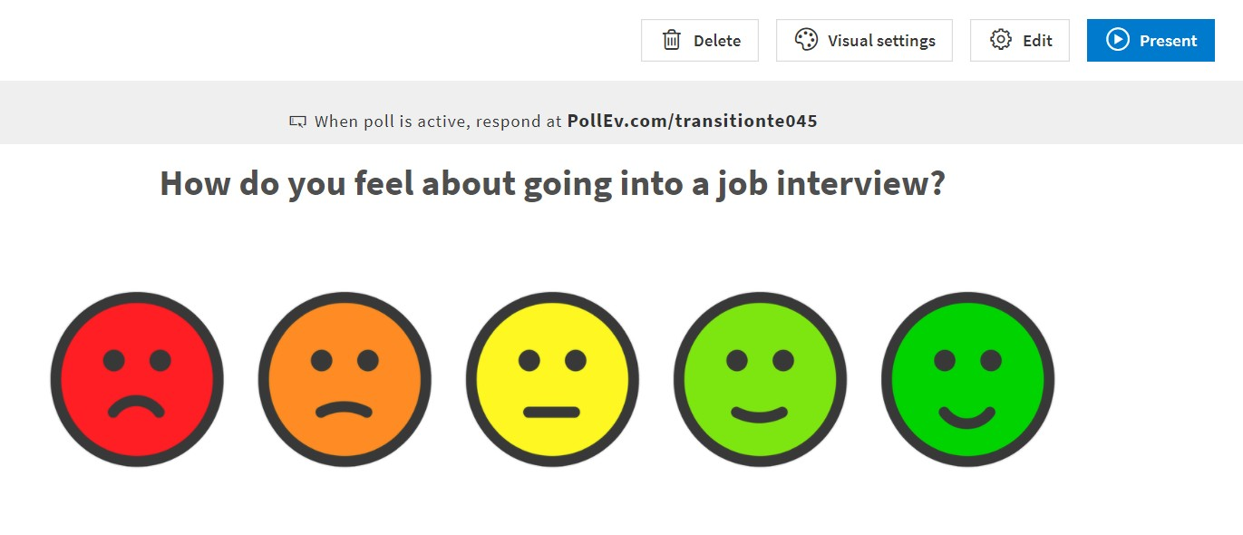
Click “Present” and share the URL with students so they can respond from their devices.
For additional information and assistance, click here to watch a tutorial.
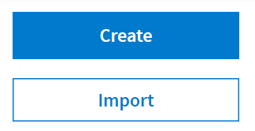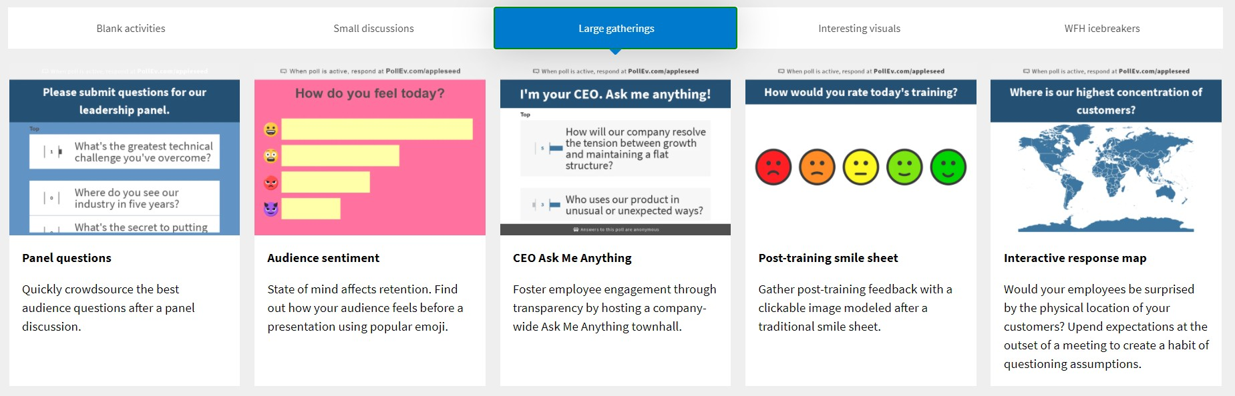
Log on to Poll Everywhere and make an account. Click “Create” to start.
Select the question type and enter your question and response options.

Quizlet

Description – https://quizlet.com
- Platform to create interactive vocabulary lists with many activity options
- Access to existing word lists and definitions
- Create your own lists relevant to your content

Pricing
- Free version available
- Upgrade to Quizlet Teacher for $3.99 a month

How to Use

Content Review: Using questions about content delivered to students in previous lessons to review concepts
  - Example: Show students the vocabulary word set from their last class, and review the words and definitions

Content Delivery: Creating questions based on the lesson’s learning target to monitor student’s
understanding throughout the lesson
  - Example: Provider shows students the definition side of a word card, and asks students to write the corresponding vocabulary word on a white board and students share their responses
    - Reverse side: When an employer talks to a potential employee about if they
would be a good fit for the job available’ (can also include photo)

Vocabulary Review: Reviewing the definition of new terms and how they can be used in context
  - Example: Provider assigns students the Match game. When they have completed the game, the provider reviews the incorrect matches with student

Assessment: Monitoring student learning
  - Under Test mode, students review study set as a quiz with multiple choice, written, and matching questions (all tests are generated by Quizlet using the word set).
  - Example: Provider assigns students the quiz to complete online, and after the students complete the quiz, provider can assign students to make corrects to their incorrect answers.

Brain Breaks: Making learning fun and engaging with a break from the lesson content
  - Play Quizlet Live in team mode with questions about students’ interests. This promotes interaction and builds communication skills and rapport.
  - Example: “What is your favorite sport?” “What is your favorite food?”

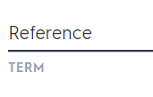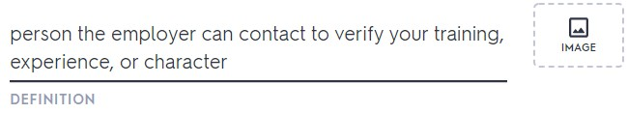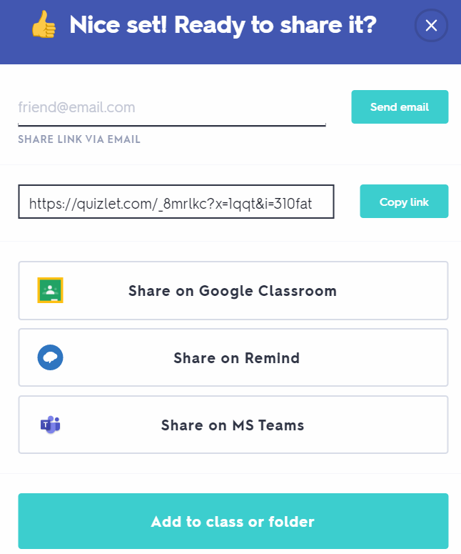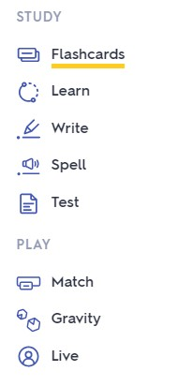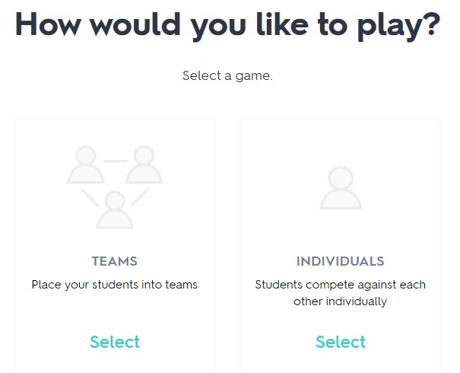

Go to Quizlet.com, sign up, and create an account

Click “Create” to make a new set of words or search to view existing sets of words.

Add terms. You can choose an existing definition or add your own.

When completed, share with students.

Students can choose their study mode for the set.

You can play a game with Quizlet Live.

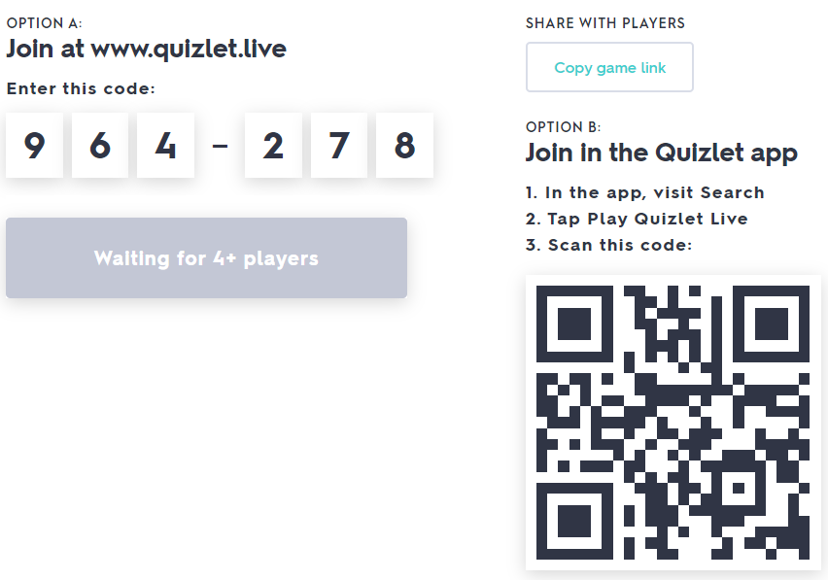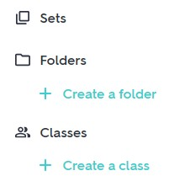For additional information and assistance click here to watch a tutorial.

Students can join with a code or can
use a QR code.

Create a class to give students access to all materials.

Remind

Description – https://www.remind.com

- Platform makes it easy to communicate with students (ages 13+) and families
- Share announcements, reminders, or links with participants
- Notifications come through the Remind App or as a text message
- All phone numbers are kept confidential

Pricing

- Free

How to Use

- Create announcements for multiple groups about events or resources. Include links for registration
  - Example: “On Tuesday September 15th from 5:30-7pm, Transition TN is hosting a Virtual Transition Fair on Independent Living Skills. For more information or to register, see: https://vanderbilt.zoom.us/meeting/register/tJIrd- mprTsrGdFPGF1dI6u2Dv-_Pm1yB736.”

- Send messages to individual classes or groups
  - Example: “Next week, we will be reviewing job applications. Come to class with a few jobs you think you would like to apply for.”

- Send messages to individual students or families
  - Example: “Sara, please submit your sample job application assignment by Friday at
3pm.”

- Receive messages from students or families
  - Example: “My son is missing information about how to get accommodations on job applications. Can you please share that with him?”

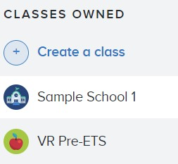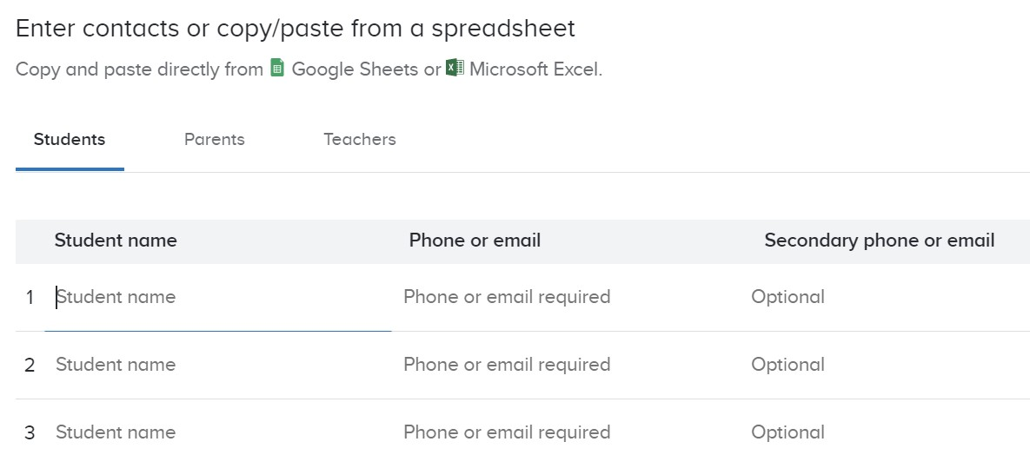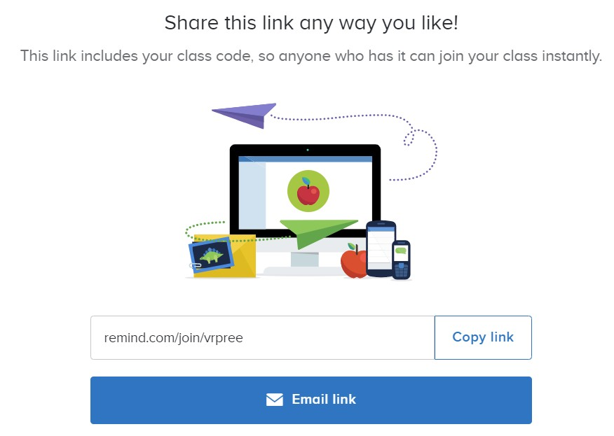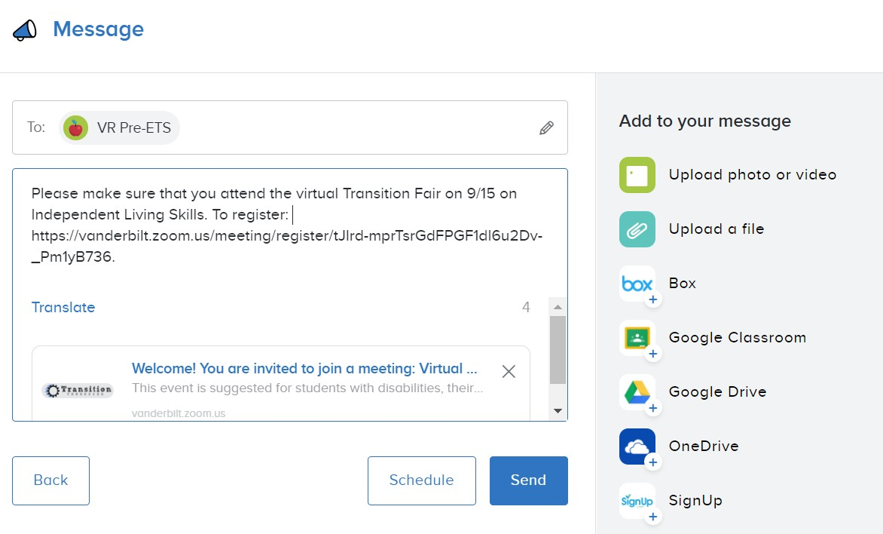
Go to Remind and create an account. Download the app to create classes or groups.
Add participants’ contacts to each class.
Remember, students must be 13+.
Share the link to add participants with the use of a class code.
Send messages to the class as a whole or individual students.
Add links to the messages as needed.

TimeStation

Description – https://mytimestation.com

- A platform that allows participants to clock in and out
- Participants can clock in and out using a QR code or a 4-digit PIN on the TimeStation app

Pricing

- Free for up to 10 participants
- $19.95/ month for up to 20 participants
- $29.95 / month for up to 50 participants
- $39.95 / month for up to 100 participants
- $59.95 / month for up to 200 participants

How to Use

- Students can create an account to practice clocking in and out
- Students are accountable for their learning time
- Students can clock in at the beginning of their sessions with Pre-ETS providers, and monitor how much time they have spent working
- For asynchronous learning, students can clock in and out when they are working on assignments and then can report their time to the Pre-ETS provider when they meet
- For additional practice, they can clock in when working on jobs around the house such as household chores

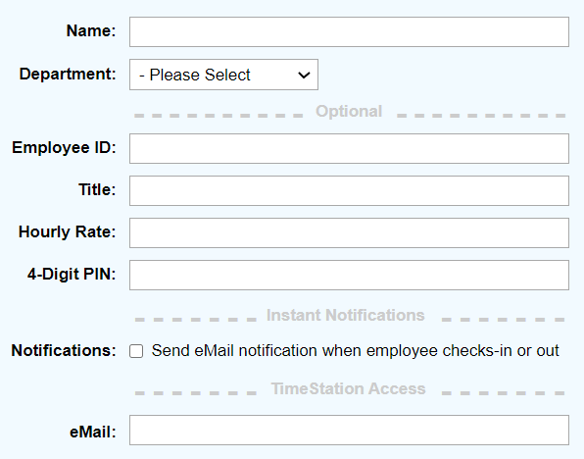
Go to TimeStation and create an account. Download the app or use the website. Add students with their name, class, and email address to invite them.

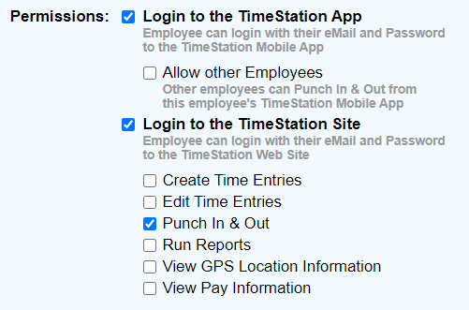
Adjust the permissions for each student so they can access the app and site.

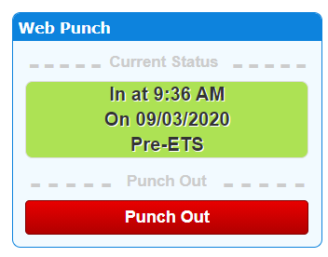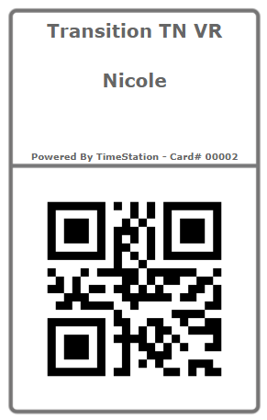
Students can practice clocking in and out.
They clock in using the website, app, or using a QR code card.

Kahoot

Description - https://kahoot.com/
- Platform that makes it easy to create, share, and play learning games and trivia quizzes
- Create engaging and interactive games with unique content
- Access to existing question bank
- Access to existing games
- Host a live Kahoot through a video call or play in class. Display questions on a shared screen, while students answer on their devices

Pricing
- Free version available
- Pro Account- $3 a month with additional features like more question types
- Premium Account- $6 a month

How to Use
Content Review: Using questions about content delivered to students in previous lessons to review concepts
  - Example: True/False Question: “Based on what we discussed last time, job applications come before an interview.”
    - Choices: True or False

Content Delivery: Creating questions based on the lesson’s learning target to monitor student’s
understanding throughout the lesson
  - Example: Multiple Choice: What are the two main forms of job applications?
    - Choices: Paper only, Electronic only, Paper and Electronic, In-person and paper

Vocabulary Review: Reviewing the definition of new terms and how they can be used in context
  - Example: Multiple Choice: Which term on a job application means the name you have before you get married?
    - Choices: Social Security Number, Maiden Name, Date of Birth, Address

Assessment: Monitoring student learning
  - Example: Multiple Choice: Which of the following would be a good professional reference?
    - Choices: 1st grade teacher, Parent, Volunteering Job Supervisor

Brain Breaks: Making learning fun and engaging with a break from the lesson content
  - Create a Kahoot about students’ in the class to gain rapport and classroom culture. You can get information about students from personal interviews (just make sure it’s information that is okay to be shared!)
  - Example: Julia likes to go swimming in her free time. Choices: True or False

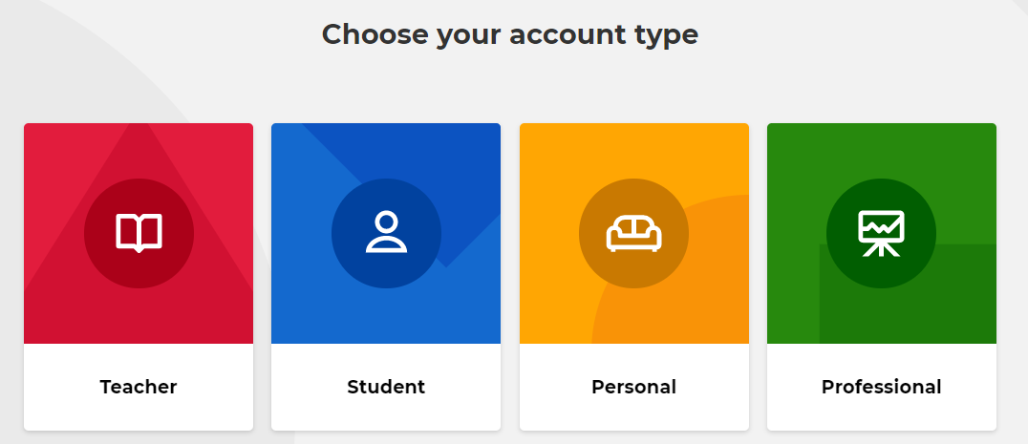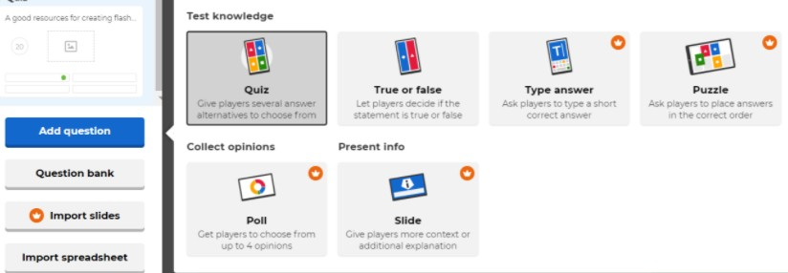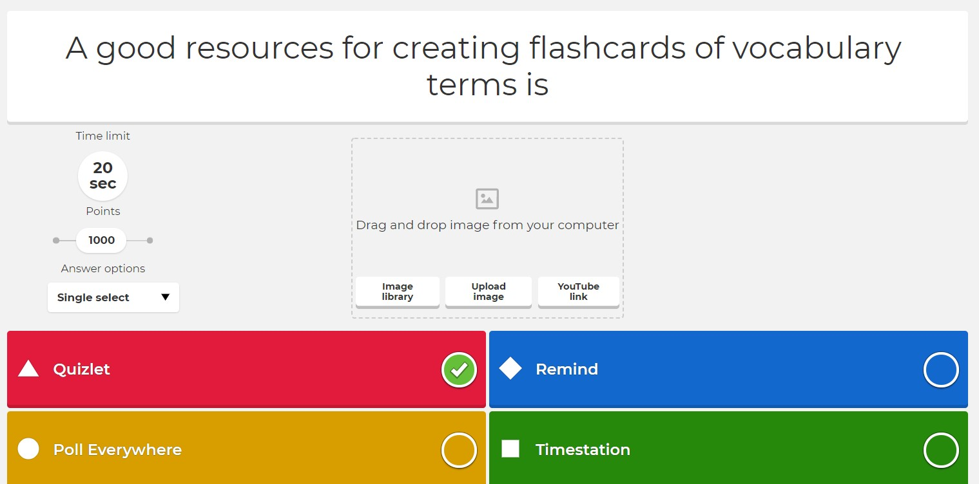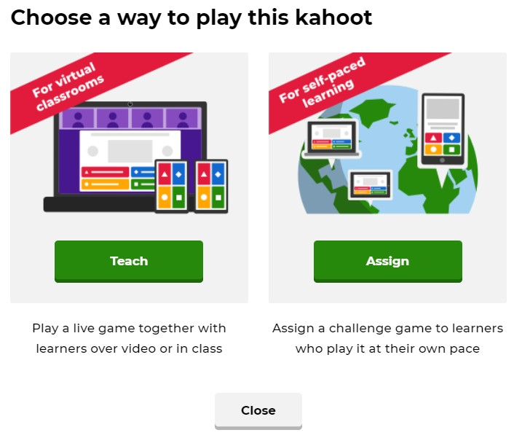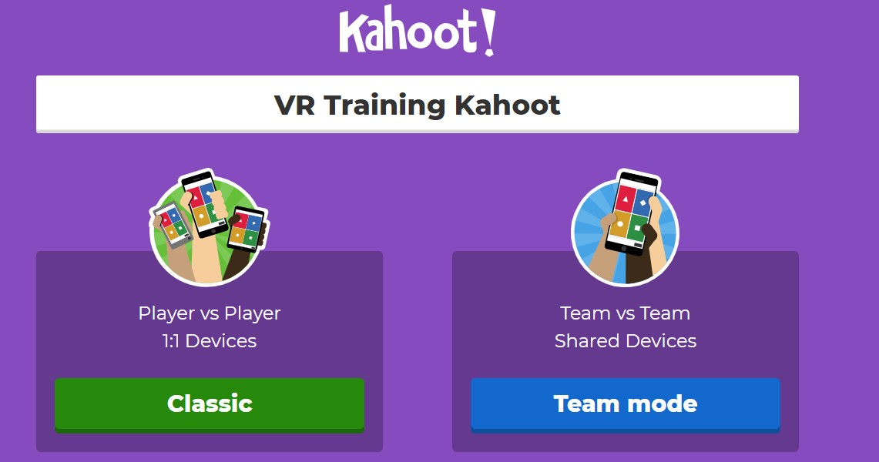

Go to Kahoot.com and sign up.

Click “Create” in the upper right corner.

Click “Add Question” and select type.

Insert the question, answer choices, and images. Adjust time limit and mark the correct answer.

Choose to play: live (left option) or self- paced (right option).

Choose Player vs Player or
Team vs Team.

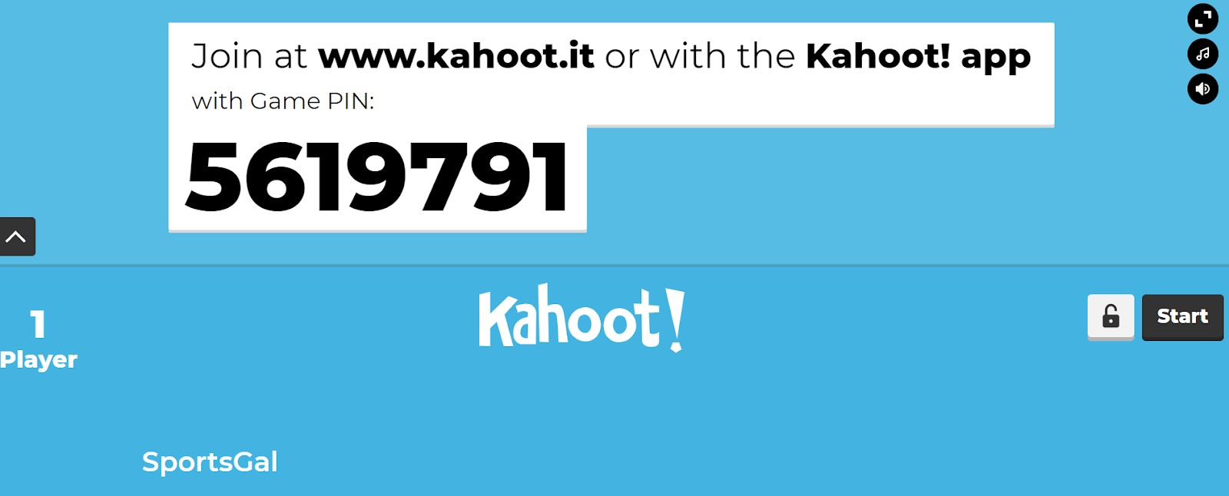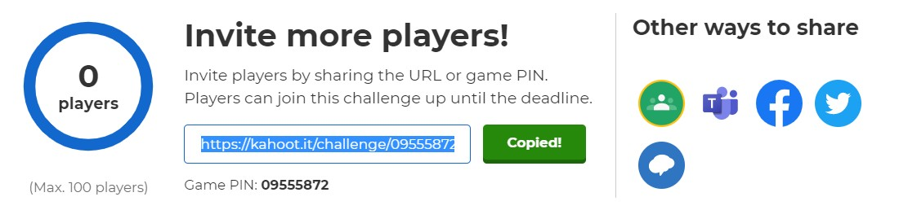For additional information and assistance click here to watch a tutorial.

Students go to www.kahoot.it and enter Game PIN. Press start when all have joined.

Share the link or insert into Google Classroom, Teams, or Remind.

Flipgrid

Description - https://flipgrid.com
- Platform that allows you to pose a question or prompt and respondents reply with a short video clip

Pricing
- Free

How to Use
Content Review: Using questions about content delivered to students in previous lessons to review concepts
  - Example: Prompt: “Why is it important to fill out a job application completely?”
Student responses may vary but can talk about how you may not get selected for an interview if application is not complete or how some information is needed for the employer to contact you.

Content Delivery: Creating questions based on the lesson’s learning target to monitor student’s
understanding throughout the lesson
  - You can add external links (i.e. Google doc, YouTube video to a topic). Example: Prompt: Preview the video about interviewing for a job and answer the following question: “Why do you think the applicant didn’t get the job?”
    - Student responses may vary but can talk about the applicant not answering questions appropriately or being rude to the employer.

Vocabulary Review: Reviewing the definition of new terms and how they can be used in context
  - Example: Prompt: “If a job application asks you for your educational background, what
are they asking for?”
    - Student responses should include an explanation of what educational background is such as degrees earned, school(s) attended, dates of attendance or graduation

Assessment: Monitoring student learning
  - You can give basic or custom feedback (adding a rubric based on needs and qualifications and give a score). Example: Prompt: “If you do not meet all of the requirements for a job, what should you do?”
    - Student responses will vary but all should say to be honest and not to lie. You should be monitoring to make sure students include that information.

Brain Breaks: Making learning fun and engaging with a break from the lesson content
  - Example: Prompt: “If you could have any job (realistic or unrealistic), what would it be and why?
Student responses would vary but could give crazy jobs like a lion tamer or an ice cream taster.

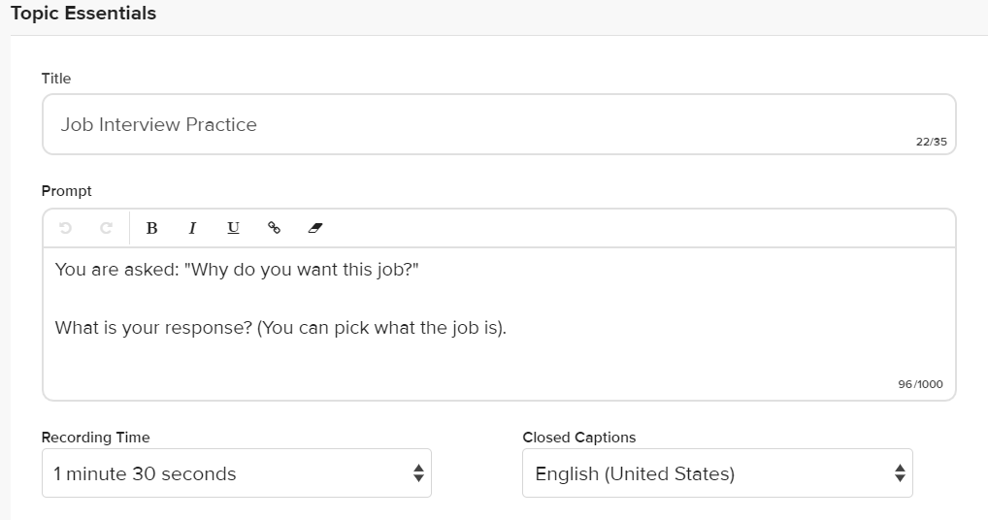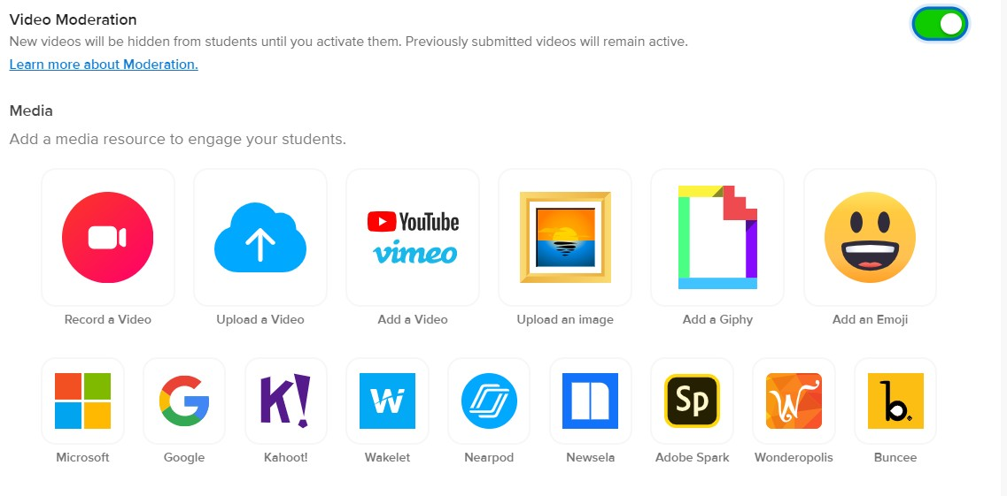Log on to Flip Grid and create a free account. Create a new topic with title and prompt.
Moderation allows you to preview videos. You can also add media to the prompt.

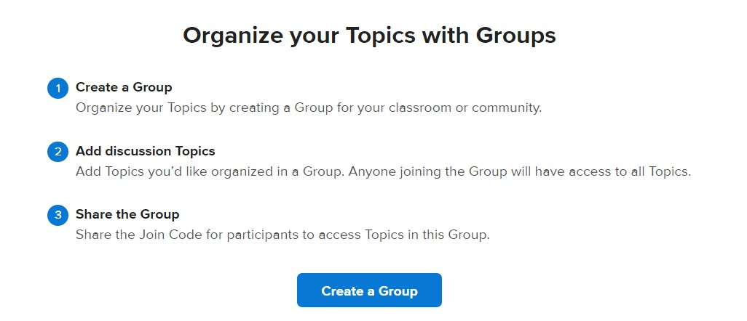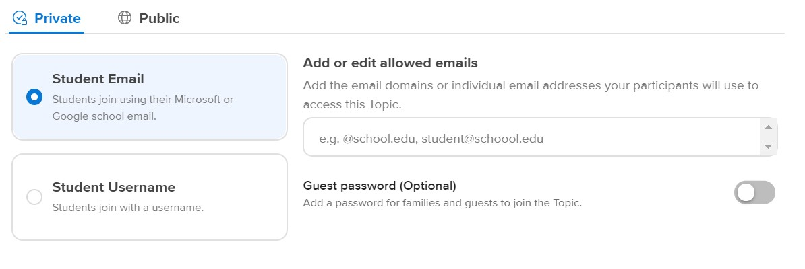

You can create a group where multiple topics can be shared.
Share with students and choose private (only selected usernames or domains can join) or public.

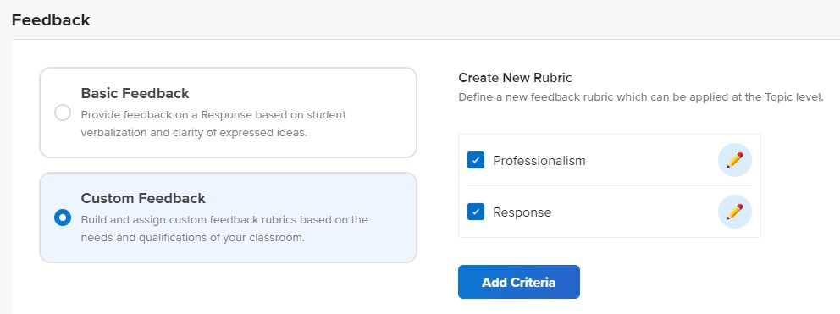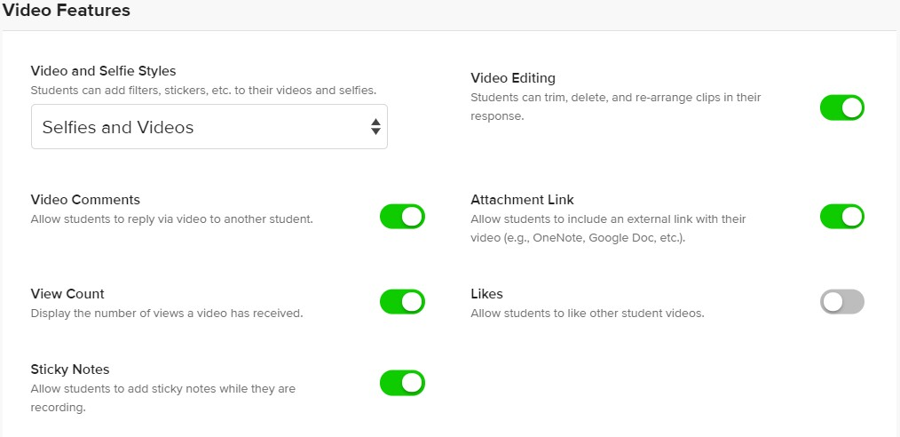Give feedback on student’s videos. Options available to add a custom

Under Video Features, turn the student comment feature
on or off.
rubric criteria.

For additional information and assistance, click here to watch a tutorial.

