United States Bureau of Labor Statistics
Employment Projection Report

The US Bureau of Labor Statistics (BLS) publishes the Employment Projection report which predicts long-term employment demand to supply job seekers with information about the labor market they will be entering. This report can assist with giving career guidance and information on how the labor market is changing. The report outlines careers that are expected to grow or decline and is broken down into numerical figures and percentages for growth or decline. A new projection is developed and released every two years that accounts for changes in consumer preferences, laws, and the United States economy.
Click here :

Features
The BLS has features on their website that can assist students with exploring careers they are interested in and help with understanding career projections.
Fastest Growing Occupations:
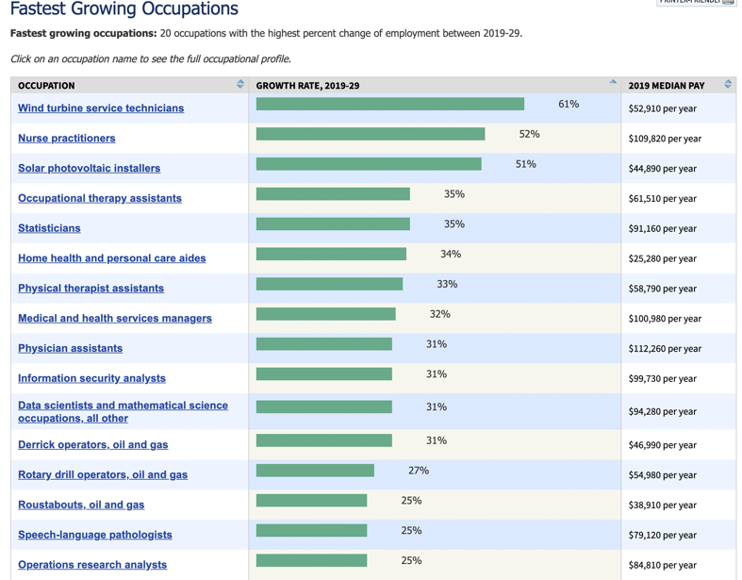
The Fastest growing occupations allows students to see what careers are projected to have the most growth, or job openings. If your students see a career they are interested in, they can click on the career to learn additional information. Students will see tabs at the top of their screen that can be selected for more information. Students can explore: “What they do” to see an in-depth overview of job duties and careers that fall under the career category. “Similar occupations” allows students to explore other jobs that are compatible with their original interest. This will broaden the students career exposure while they learn more about possible in demand job options.

Career Outlook https://www.bls.gov/careeroutlook/
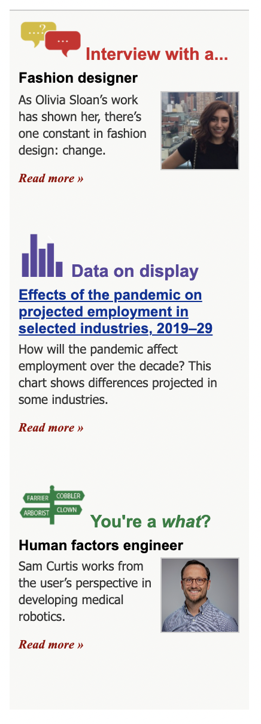
“Interview with a …” - is a question-and-answer format that takes a look at a specific worker’s career path within their chosen career to expose students to common careers.
students can review:
        - Overview of a typical workday
        - entry level requirements
        - career paths
        - what individuals like about their career

“Data on display” - provides visual representations of data on employment and career projections. Students can select different sections of data that they may be interested in.
        - Providers can have monthly or bi-monthly check-ins with students to ensure they are staying up to date on labor market changes.
        - “occupations that have it all” look at job openings, wages, and expected job growth.
        - Some of the “data on display” are interactive and students can see the differences between the data on the graphs.

“You’re a what?”- explores unique jobs by describing the occupation, explaining the education or training needed, and discussing employment growth and median wage. This feature exposes students to unique careers and gives them the perspective of someone a currently working in that specific field.
        - view interviews with an individual that is currently in their career of interest.
        - Questions about the career path, required education, and how they prepared for this career.

