Exploring Skills Needed for Desired Jobs
A Career Awareness Exploration Activity

Complete the steps in this guide to learn more about what skills are needed for specific jobs. In this activity, you will use the tracking sheet to identify skills and label them as technical or soft. Learning about the skills needed for a certain job can help you find jobs that match with your strengths. Knowing what skills you need to work on, or work towards, can also help you prepare to become a strong job applicant.

Steps | Website Navigation
The first step in this activity is to have a desired job identified or a few jobs to compare. List the jobs in the open box.
Pick a job search engine to search for current job postings.

Some common search engines include Indeed, LinkedIn, Glassdoor, ZipRecruiter
Once a search engine is selected, the website will ask what type of job you are looking for and where you are looking.  Type the desired job title into the “What” box and select find jobs.  *For the purpose of this activity, the WHERE is not as important*  After clicking search, a list of relevant job posting will come up. | 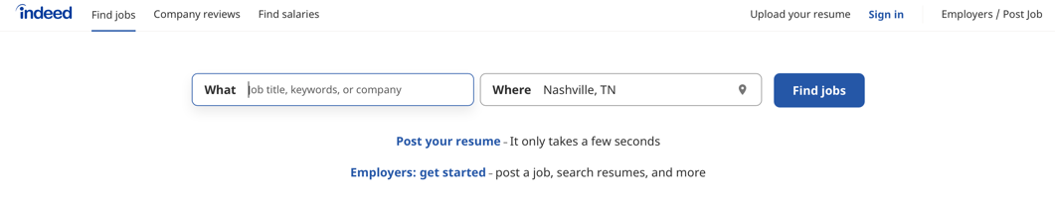  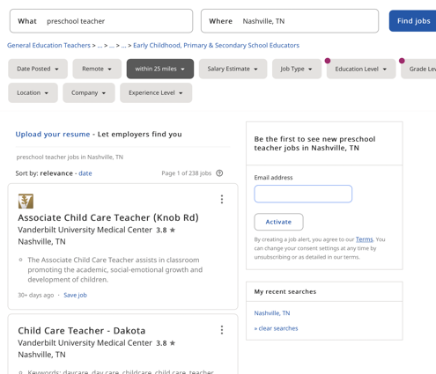
Begin to click on different job postings. Read through the descriptions and requirements/qualifications.  Requirements and qualifications are going to be in the keywords to look for about the skills that are needed.  The job description and responsibilities can suggest additional information about helpful skills to be successful in the job role. | 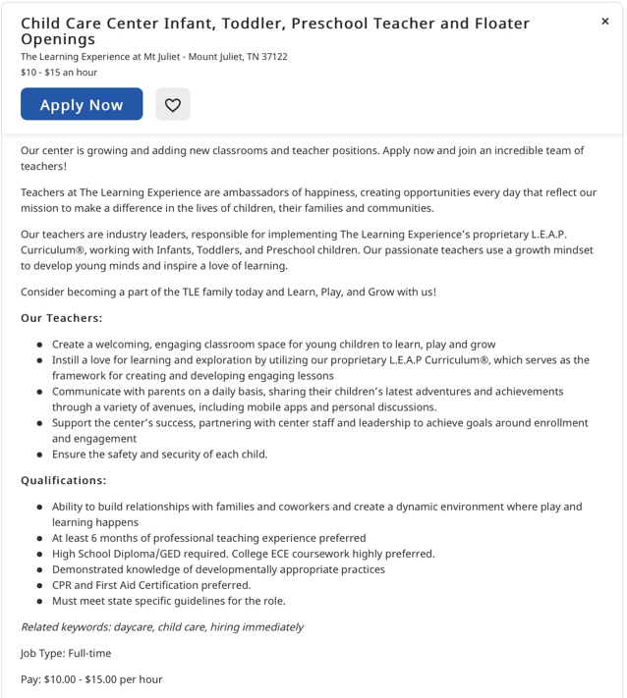  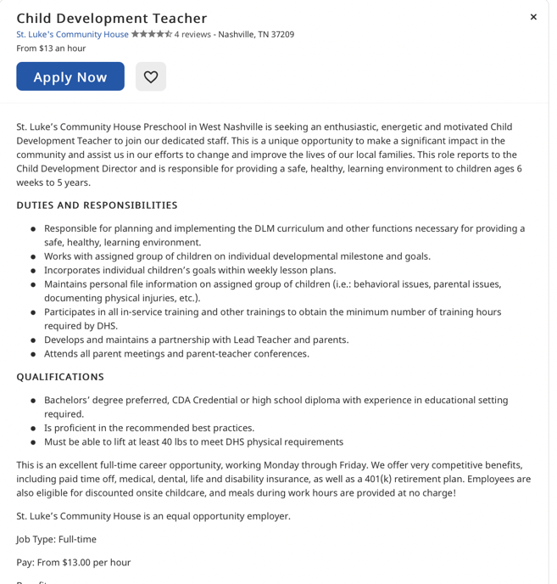  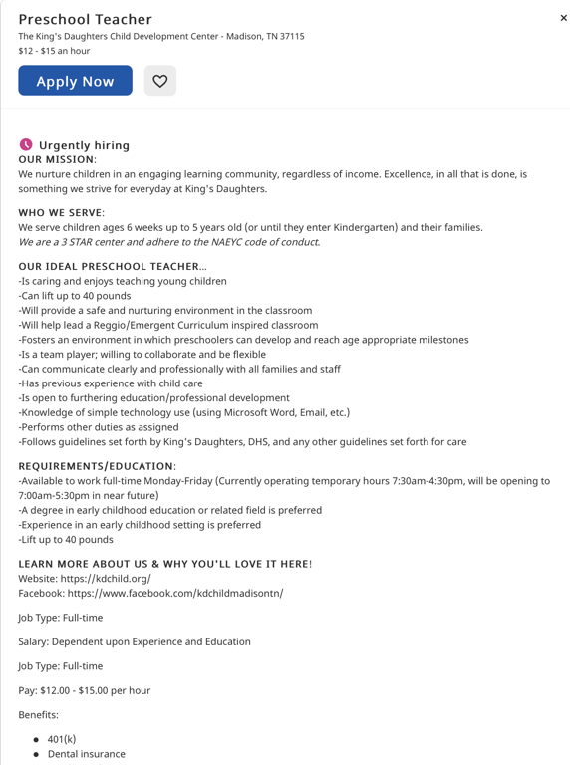

Use the skills tracking worksheet to keep track of the skills you discover in your search.  You can begin to identify which skills are soft skills and which skills are technical skills.  In this picture the soft skills and the technical skills are identified through the arrows. | 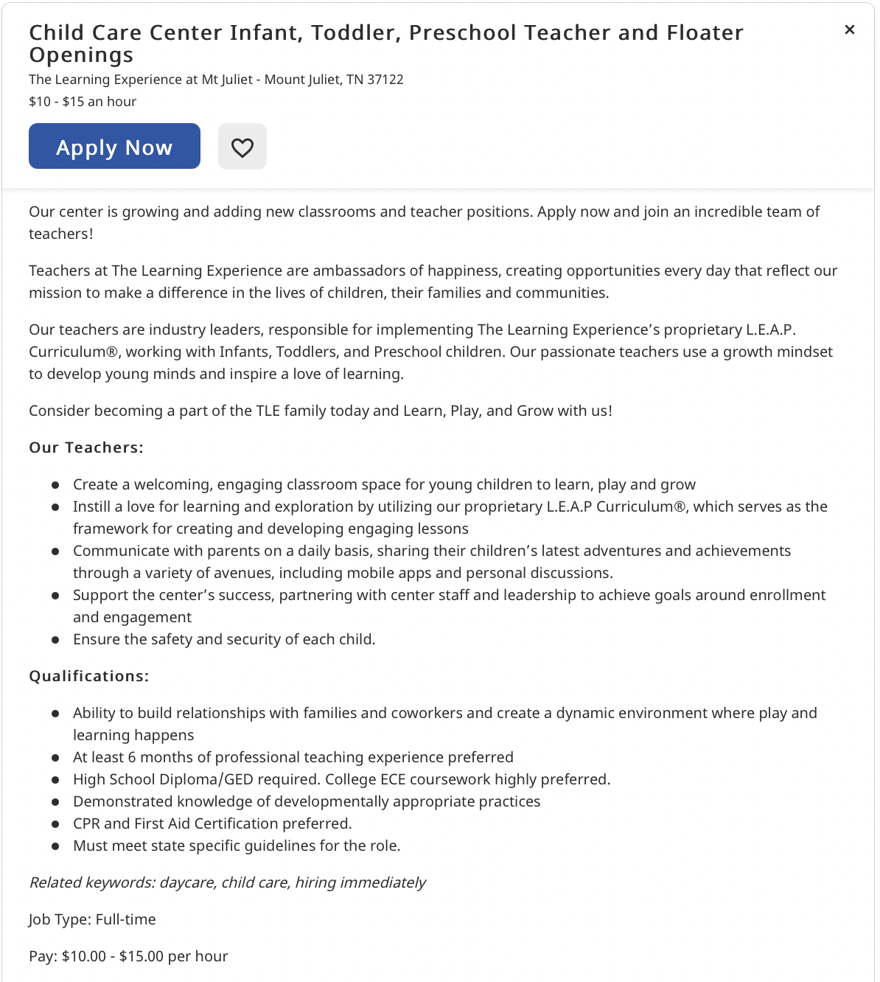  Soft skills  Technical skills  Soft skills

Skills Tracking Worksheet

Job Title: ___________________________________________

Job Skill | Soft Skill | Technical Skill
Example: CPR and First Aid Certification
Example: Ability to build relationships with children and families

