Navigating the Labor Market in Your Area: An Exploration Resource for Students

Provider Instructions: Use this resource to assist your students with exploring the labor market.
- Students will need to know what county they live in for the activity. For those students that are unsure of their county, help them learn this information.
- This activity could be used at the beginning of job exploration before students have selected a career of interest, or parts can be adapted toward a certain career of interest.
  - If you adapt certain parts toward a specific career of interest, make sure to have students investigate the area profile. The area profile will indicate how their career of interest is projected to do in that area.
- Links and screenshots have been provided for each part of the Jobs4Tn student resource. Assist your student with using the links and screenshots to navigate the Jobs4Tn website.
- This activity can be done more than once. The labor market will change and it’s important for students to see how career projections shift overtime.
- When students are comparing different jobs and the labor market, the students career preferences may change. If new career interests spark out of this activity, it would be beneficial to help students explore those new careers.

Navigating the Labor Market in Your Area: An Exploration Resource for Students

Students: Use the following instructions and guide to learn more about available jobs in your area. Remember, available jobs are always changing. You may want to revisit this search monthly and update it with the most recent information or as your career interests change.

Steps | Website Navigation | Notes or Findings
Log onto Jobs4TN.gov.  Recommended: Make an account for an Individual. (This may take about 25 minutes.)  You can also use “Guest Access”, but will not be able save your information. | 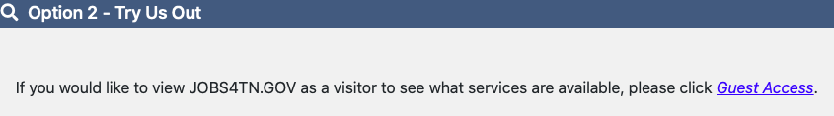 | Use the extra space at the bottom of this page to record your log in information or have your computer remember it for future use  Upload any information to the website, including your resume if you have one.
From the Home page, access Labor Market Services.  Return to this home page to navigate to the various tools. | 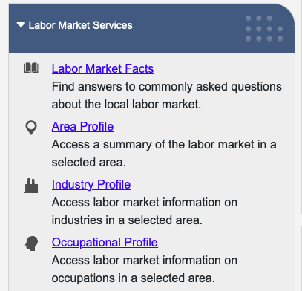 | - What county do you live in?  - What Industry are you interested in?  - What job(s) or occupation(s) are you interested in?
To search for general information about the Labor Market in your region, select Area Profile. Set Area Type to County and select your county from the dropdown list. | 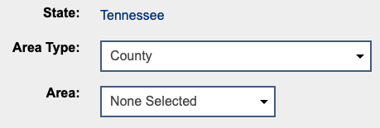  Select  Select | What are the top growing jobs or occupations in your county?  Which employers have the most job openings?
To search for information on an industry in your area, select Industry Profile. You can search by keyword, sector, or listing. |  | In the _____________ industry:  Which jobs or occupations have the highest estimated employment?
After selecting an industry in the last step, locate your county on the map (hover over to see the county names).  The left map shows number of employers by county and the right map shows how many jobs are currently advertised per county. | 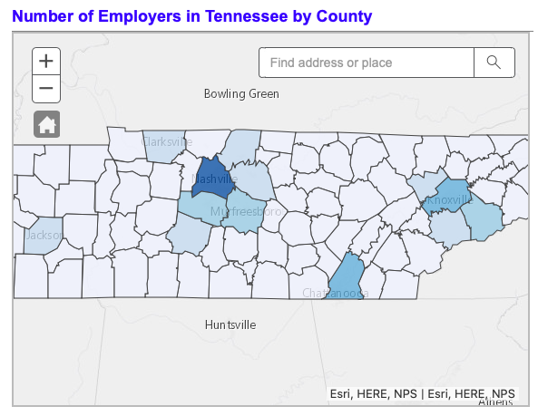 | - How many employers are there in your county for the ___________ industry?  - Using the map on the right, how many advertised jobs are there for this industry in your county?
Using the Occupational Profile, select an occupation by keyword, group or listing. | 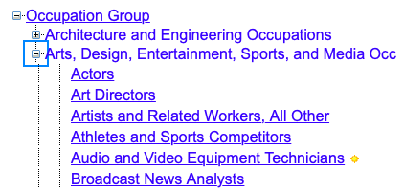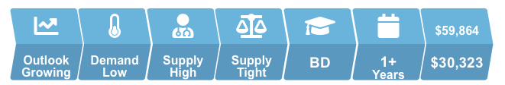 | In the __________________ occupation:  - What is the outlook for this job?  - What is the current demand for this job?
After selecting an occupation in the last step, locate your county on the map (hover over to see the county names).  The left map shows number of advertised job openings by county for that occupation. | 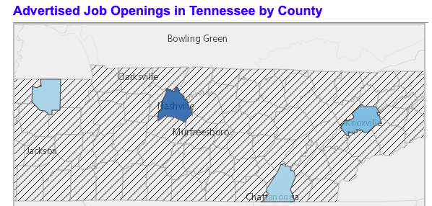 | How many advertised job openings are there in your county?

